Task -1
Category Type Real Life Usage
Printer Inkjet Printer Printing college assignments and color photos
Printer Laser Printer Printing office documents and reports
Printer 3D Printer Creating prototypes and small 3D models
Scanner Flatbed Scanner Scanning certificates and documents
Scanner Sheet-feed Scanner Scanning Multiple Pages In an Office
Webcam Built-in Webcam Attending online classes or video meetings
Webcam USB Webcam Live streaming and desktop video calls

Task-2
1.USB Connection (Wired)

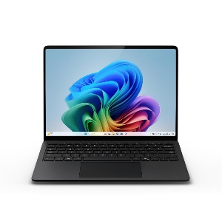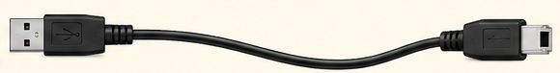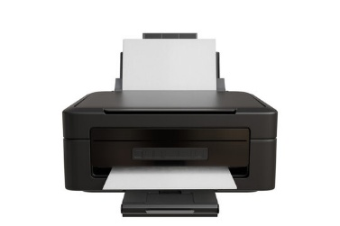

2.Wifi Connection (Wireless )
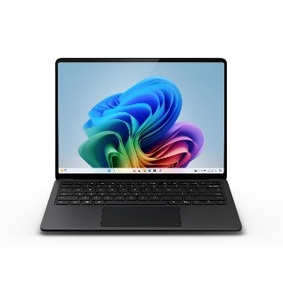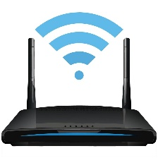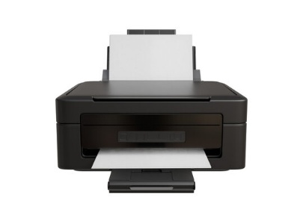

3.Bluetooth Connection (Wireless)
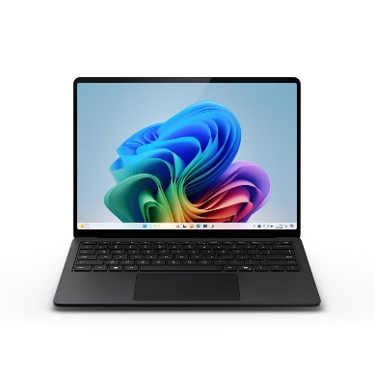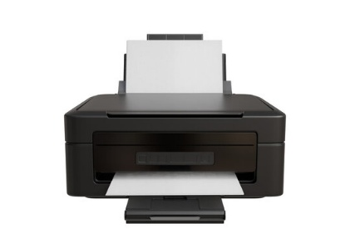

Task-3
Connection Interface Advantage Disadvantage
Usb Fast and reliable connection Requires a physical cable
Wifi Wireless and convenient for Requires a wifi network
multiple devices
Bluetooth Easy Wireless connection without cables shorter range and generally
slower than Usb
Task-4
Device: Printer
Method : USB Cable
- Turn on the printer and the computer
- Take a USB printer cable (USB type-A to USB type-B cable )
- Connect the USB type-A end to the computer and the USB type-B end to the printer
- Wait for the computer to detect the printer automatically
- If required, install the peinter driver/software provided by the manufacturer
- Open settings – bluetooth&devices – printer&scanner on windows
- Check that the printer appears in the list
- Select the printer and choose print and test page to check the connection
- The printer is now ready to print document and photos

